**Challenge 1 - Steve's Car Showroom**

**Introduction**

Steve runs a top-end car showroom but his data analyst has just quit and left him without his crucial insights.

Can you analyse the following data to provide him with all the answers he requires?

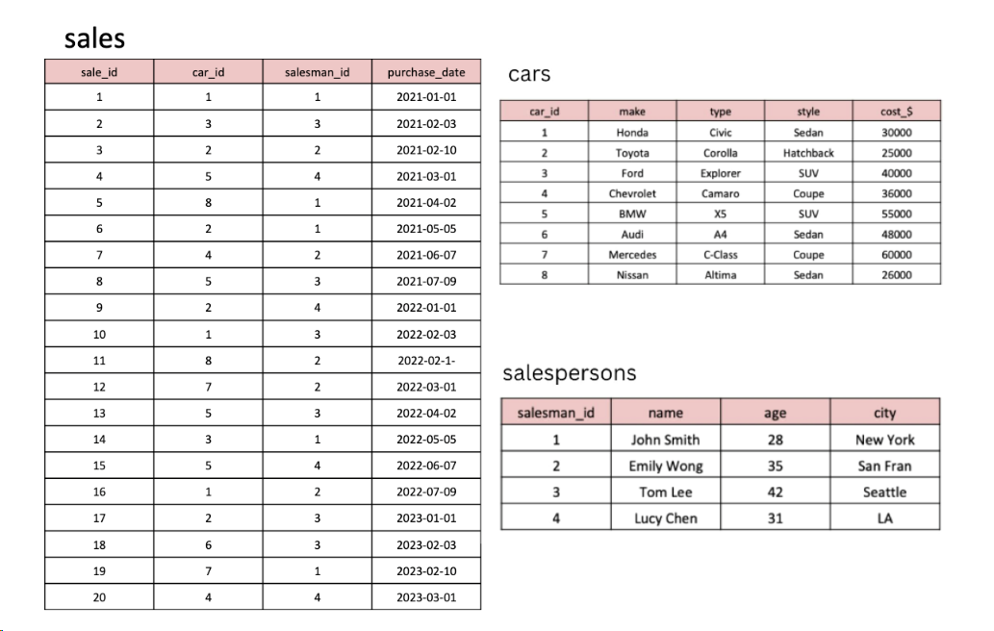

**Questions**

**Answer the following questions**

1. What are the details of all cars purchased in the year 2022?

2. What is the total number of cars sold by each salesperson?

3. What is the total revenue generated by each salesperson?

4. What are the details of the cars sold by each salesperson?

5. What is the total revenue generated by each car type?

6. What are the details of the cars sold in the year 2021 by salesperson 'Emily Wong'?

7. What is the total revenue generated by the sales of hatchback cars?

8. What is the total revenue generated by the sales of SUV cars in the year 2022?

9. What is the name and city of the salesperson who sold the most number of cars in the year 2023?

10. What is the name and age of the salesperson who generated the highest revenue in the year 2022?

**DDL Commands**

CREATE TABLE cars (

car_id INT PRIMARY KEY,

make VARCHAR(50),

type VARCHAR(50),

style VARCHAR(50),

cost_$ INT

);

--------------------

INSERT INTO cars (car_id, make, type, style, cost_$)

VALUES (1, 'Honda', 'Civic', 'Sedan', 30000),

(2, 'Toyota', 'Corolla', 'Hatchback', 25000),

(3, 'Ford', 'Explorer', 'SUV', 40000),

(4, 'Chevrolet', 'Camaro', 'Coupe', 36000),

(5, 'BMW', 'X5', 'SUV', 55000),

(6, 'Audi', 'A4', 'Sedan', 48000),

(7, 'Mercedes', 'C-Class', 'Coupe', 60000),

(8, 'Nissan', 'Altima', 'Sedan', 26000);

--------------------

CREATE TABLE salespersons (

salesman_id INT PRIMARY KEY,

name VARCHAR(50),

age INT,

city VARCHAR(50)

);

--------------------

INSERT INTO salespersons (salesman_id, name, age, city)

VALUES (1, 'John Smith', 28, 'New York'),

(2, 'Emily Wong', 35, 'San Fran'),

(3, 'Tom Lee', 42, 'Seattle'),

(4, 'Lucy Chen', 31, 'LA');

--------------------

CREATE TABLE sales (

sale_id INT PRIMARY KEY,

car_id INT,

salesman_id INT,

purchase_date DATE,

FOREIGN KEY (car_id) REFERENCES cars(car_id),

FOREIGN KEY (salesman_id) REFERENCES salespersons(salesman_id)

);

--------------------

INSERT INTO sales (sale_id, car_id, salesman_id, purchase_date)

VALUES (1, 1, 1, '2021-01-01'),

(2, 3, 3, '2021-02-03'),

(3, 2, 2, '2021-02-10'),

(4, 5, 4, '2021-03-01'),

(5, 8, 1, '2021-04-02'),

(6, 2, 1, '2021-05-05'),

(7, 4, 2, '2021-06-07'),

(8, 5, 3, '2021-07-09'),

(9, 2, 4, '2022-01-01'),

(10, 1, 3, '2022-02-03'),

(11, 8, 2, '2022-02-10'),

(12, 7, 2, '2022-03-01'),

(13, 5, 3, '2022-04-02'),

(14, 3, 1, '2022-05-05'),

(15, 5, 4, '2022-06-07'),

(16, 1, 2, '2022-07-09'),

(17, 2, 3, '2023-01-01'),

(18, 6, 3, '2023-02-03'),

(19, 7, 1, '2023-02-10'),

(20, 4, 4, '2023-03-01');